Code Review: I2305200
Reviewer: Mark Dell
Date: May 15th, 2023

* Bugs
- The Document Storage path was intended to default to the path setup in Company Setup for each new entry. This change means it no longer will.
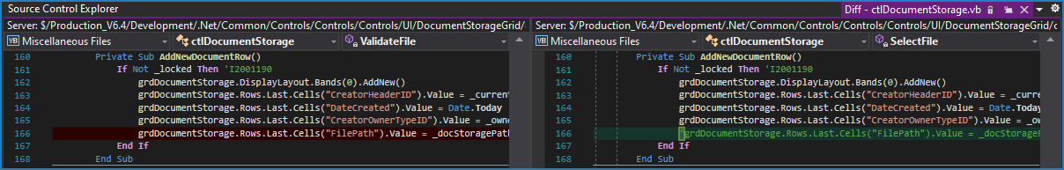
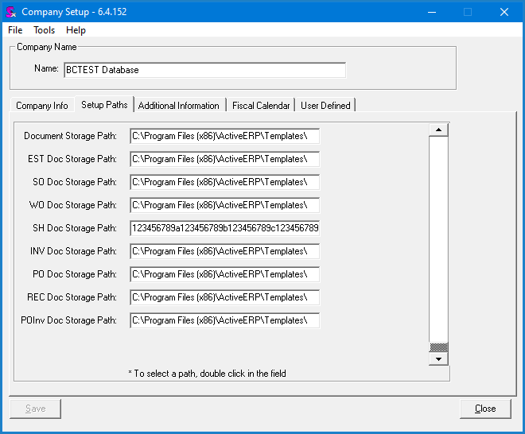
Note that it appears it is a bug that was not detected in VB6, or at least not addressed. This seems to be a conflict between setting the default path and allowing it to remember the path. The new behaviour means that the default path will no longer be used at all. The old behaviour in VB6 meant that the default path would only be respected the first time a user goes to select a file, although each module may respect it the first time.
Perhaps it would be best to maintain the path for as long as the form is open, but reset back to the default when re-opened, or maybe a separate transaction is selected. Note that this is used by several modules and as such can have a wide-reaching affect beyond service order. This likely needs to be discussed to officially decide on the desired behaviour.

Preventative Action/Safety

Design/Architecture (Duplication, appropriate project, namespaces, maintainability)

Data Model (Naming, good design, needs index?)

Performance (Minimize DB hits, excessive loops, queries, scalable)

UI (Alignment, naming, standardization, tab order)

Error Handling (Behind events, appropriate parameter checking)

Cleanup (Dispose code, remove handlers, large data objects)

* Readability (Well-named variables, methods, clear algorithm, is it understandable)
- Nit: When modifying code, we rarely comment out the old code anymore (line 186). Instead, we just remove it, and some put a reference to the ticket number that it was modified for.
Keeping the old code is partly a holdover from before we had TFS, and it has been decided that it is no longer warranted. TFS should help us enough that we don’t need to keep a bunch of old, commented out code lying around our codebase.
- Nit: Variable declaration is usually declared at the top of the method if the method is short or it is used throughout. In the case where variables are declared within, it either starts as the first line of indented code, or has a newline before, and in both cases would have a newline after to ensure it is more visible.
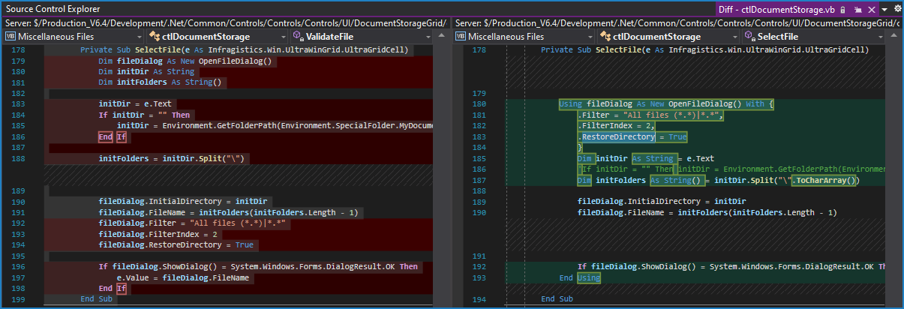

Comments (Useful, explains why rather than how)

Message Boxes (Grammar, spelling, captions, appropriate icons)

Ticket Management (Release Branch?, Testing Notes)

Extras

